Curriculum Tab Instructions
This module is provided as a benefit to programs to track where and how the competencies are taught and evaluated. It allows the program to enter all of the AT courses and map competencies to a specific course(s). It allows the program to map competencies to instructional method(s) and evaluation method(s) across courses. This module is NOT REQUIRED for Annual Reports.

To mark curriculum as complete, the following criteria should be met:
- All courses should have an uploaded syllabi
- All competencies should be mapped to at least one course
- All competencies should be mapped to at least one Instruction/Evaluation method

Adding Courses
- Navigate to the Curriculum tab > Courses
- Click ‘Add Course’

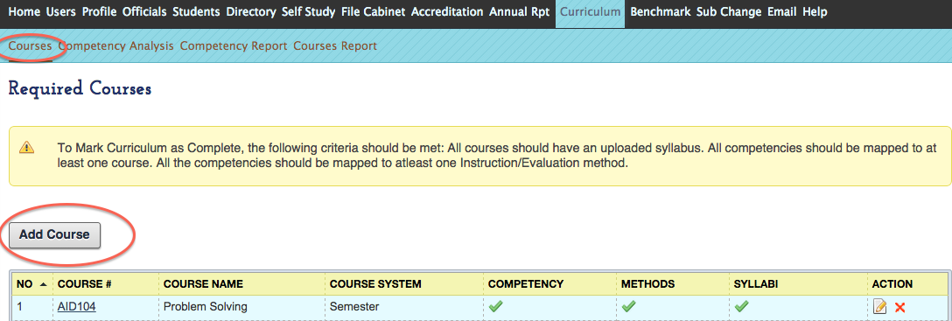

- Enter the course title, course number, and assigned credits
- Provide your course syllabi for the course by clicking ‘Upload file’

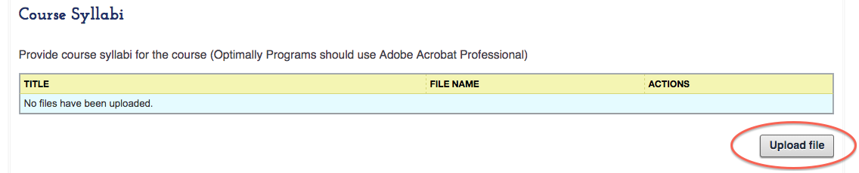

All core AT courses need to be included within the curriculum tab
- When entering course information and when a course is offered, a program can choose to use ‘Pre, Year 1, Year 2, Year 3, Year 4, and Year 5’ two different ways:
  - Year 1: First year (freshman) at the institution OR
  - Year 1: First year in the “professional” phase of the program
- If a course if offered in multiple semesters that should be indicated (e.g. Year 1 Fall, Year 1 Spring, etc.)
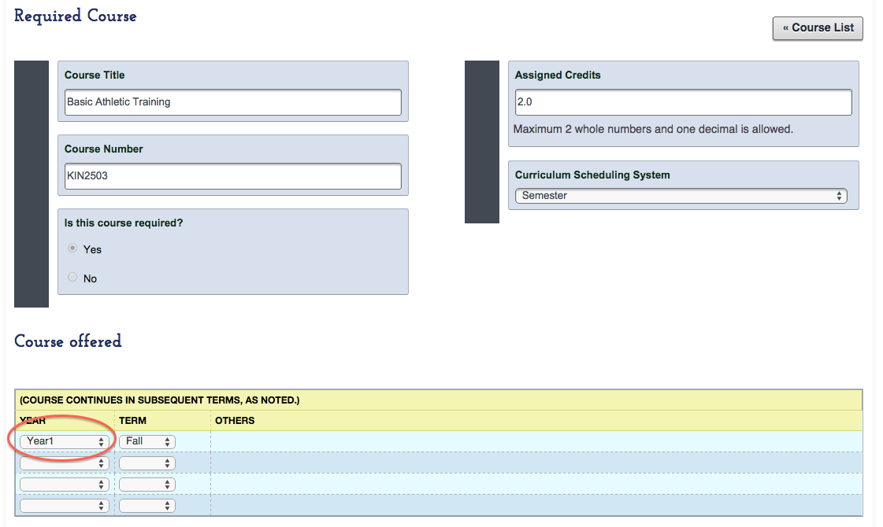

- You can then start to add competencies to the course

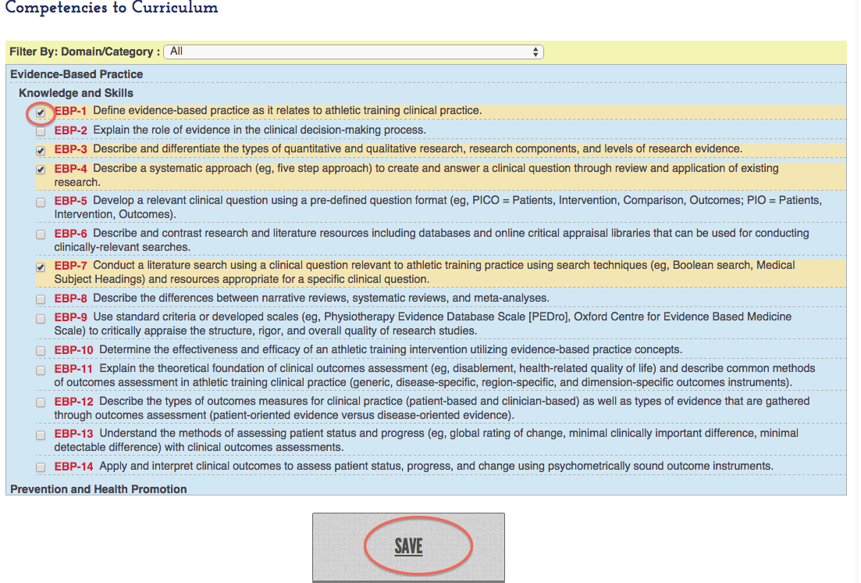

- The competencies can also be sorted by Domain

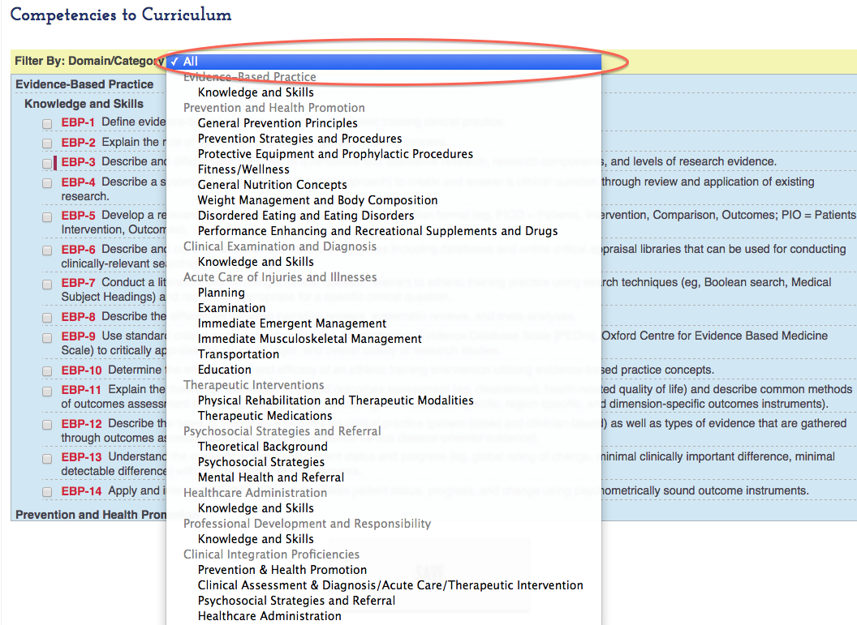

- Always remember to click Save after entering information
- Competency icons DO NOT change color when mapping to a course. Competencies will only change color once the instruction and evaluation method have been mapped to that competency (see below).

Mapping Competencies
It is suggested that you complete mapping the competency to the courses first. Then go back and map the competencies to the instructional and evaluation methods used for that competency irrespective of the course(s) where they are contained.

- The quick view bar allows you to see which competencies have been mapped to at least one instructional method and one evaluation method. The boxes don’t turn color when attached to a course.
- Please note: The competencies only turn green when they are mapped to at least one instructional method and one evaluation method. That process is independent of matching to specific courses, as it is the expectation that competencies will be addressed in several courses thus they don’t turn green until mapped to the instructional method(s) and evaluation method(s).

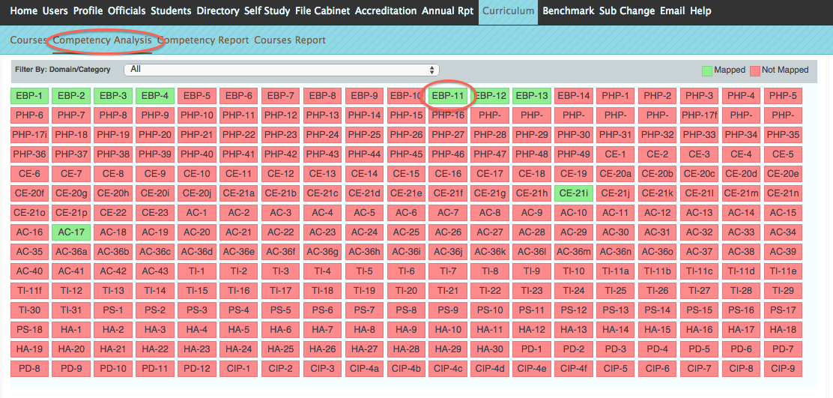

- To select the Instruction and Evaluation Method for each competency, click on ‘add mapping’

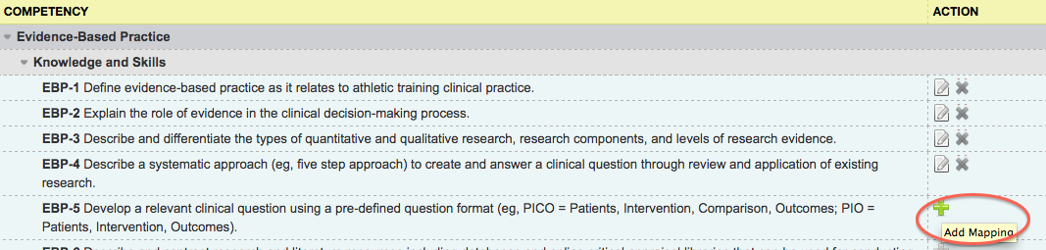

- Indicate where the competency is taught and evaluated in

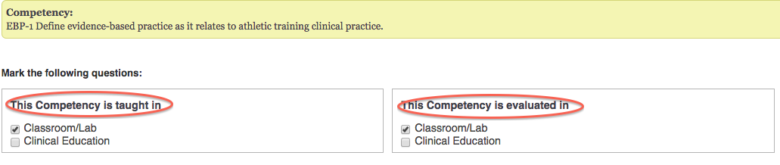

- Select the Instruction and Evaluation Method for each competency

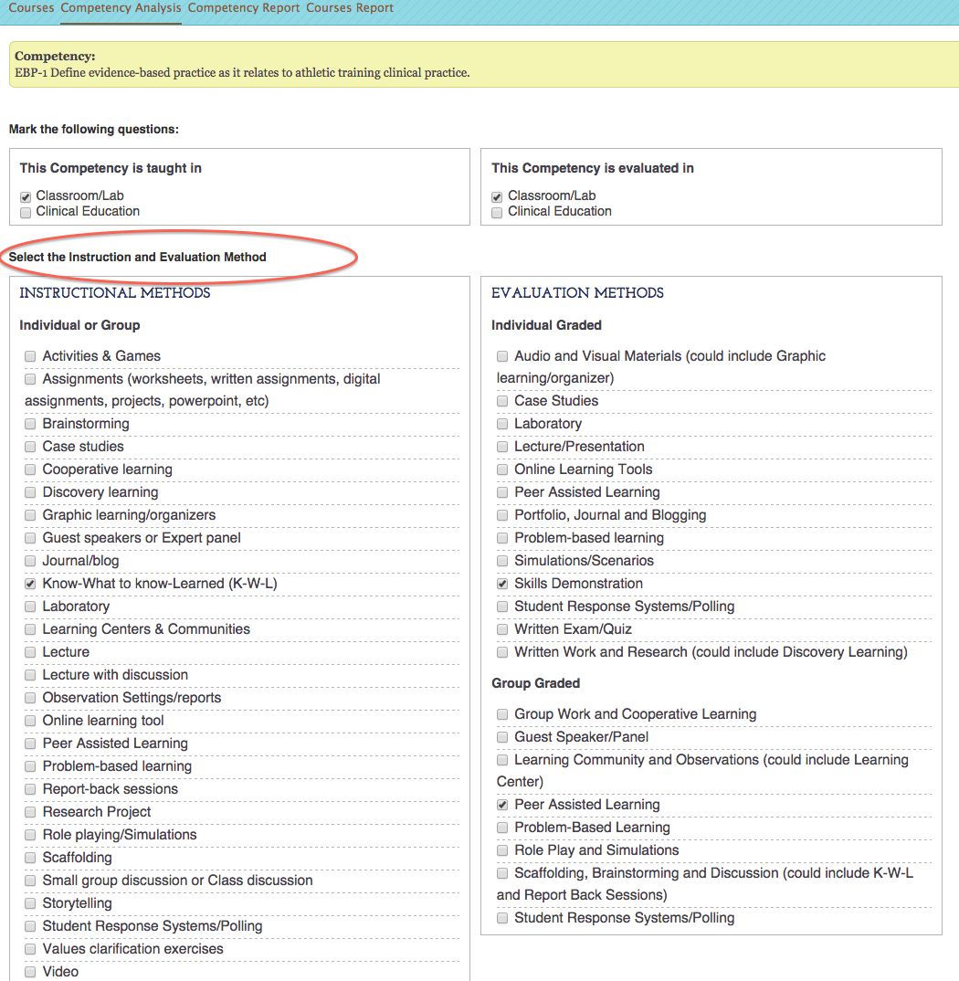

- The Curriculum will be complete when all courses have uploaded syllabi, all competencies are mapped to at least once course, and once all competencies have been mapped (screen shots below):

